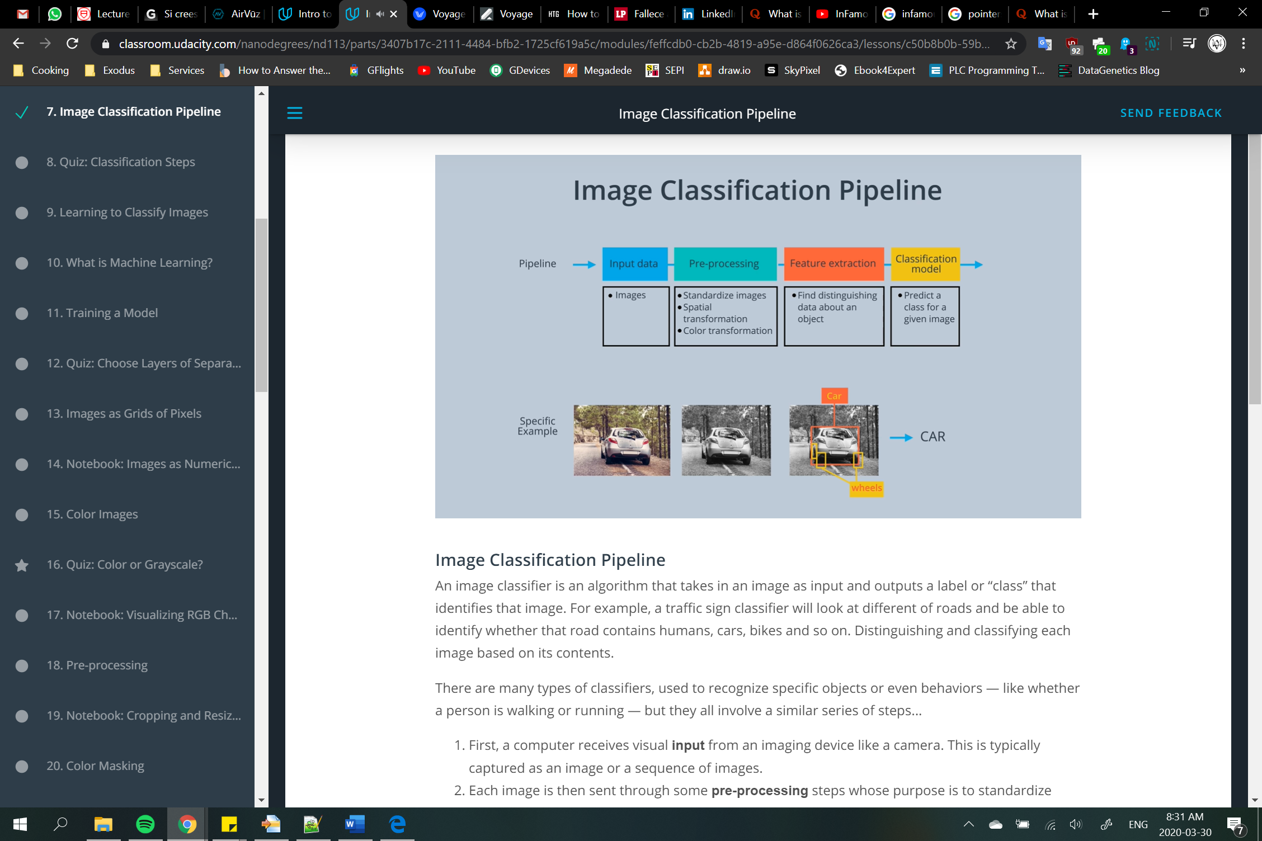

1. First, a computer receives visual **input** from an imaging device like a camera. This is typically captured as an image or a sequence of images.
2. Each image is then sent through some **pre-processing** steps whose purpose is to standardize each image. Common pre-processing steps include resizing an image, or rotating it, to change its shape *or* transforming the image from one color to another - like from color to grayscale. Only by standardizing each image, for example: making them the same size, can you then compare them and further analyze them in the same way.
3. Next, we **extract features**. Features are what help us define certain objects, and they are usually information about object shape or color. For example, some features that distinguish a car from a bicycle are that a car is usually a much larger shape and that it has 4 wheels instead of two. The shape and wheels would be distinguishing features for a car. And we’ll talk more about features later in this lesson.
4. And then, finally, these features are fed into a **classification model**! This step looks at any features from the previous step and predicts whether, say, this image is of a car or a pedestrian or a bike, and so on.

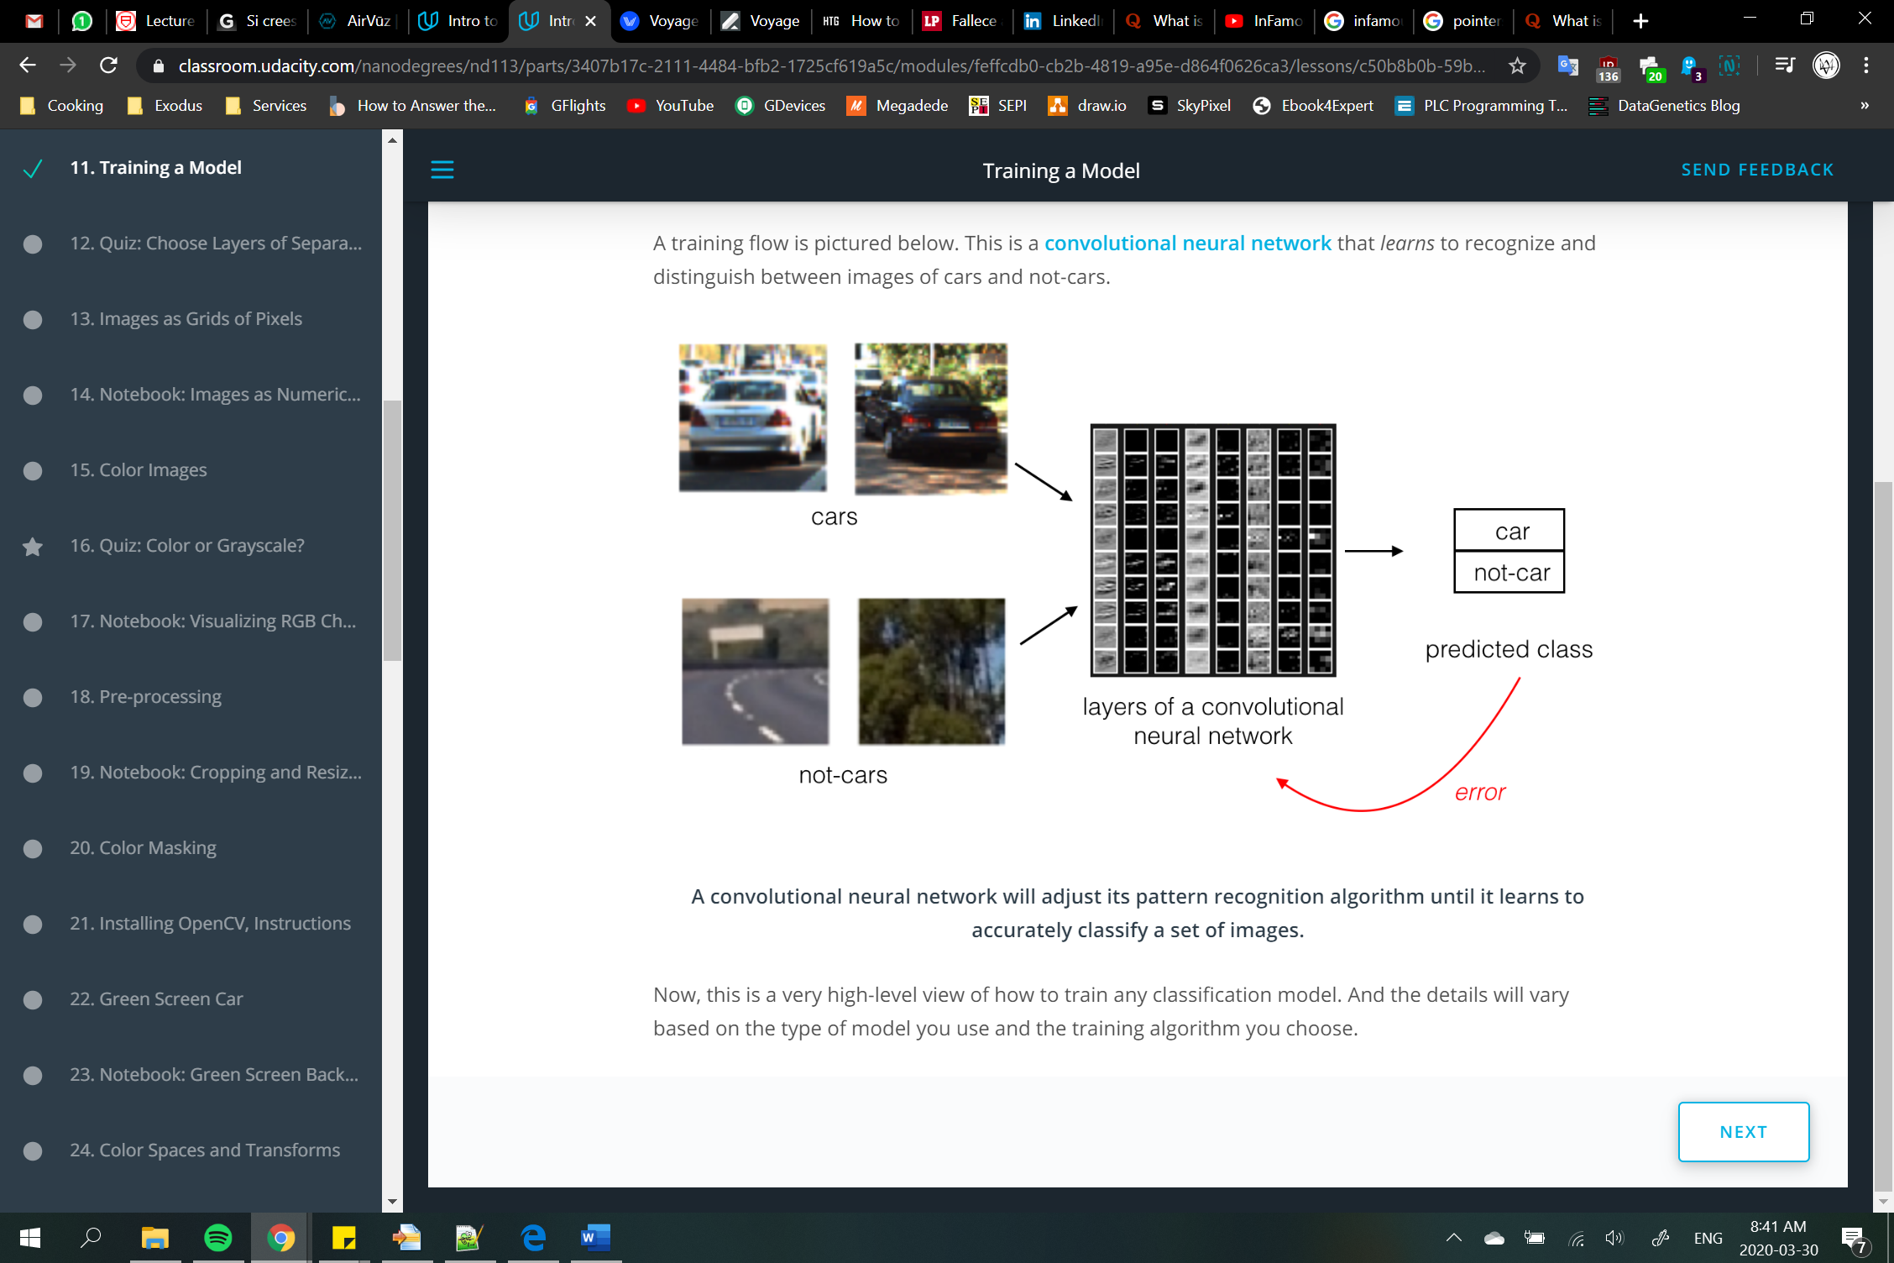

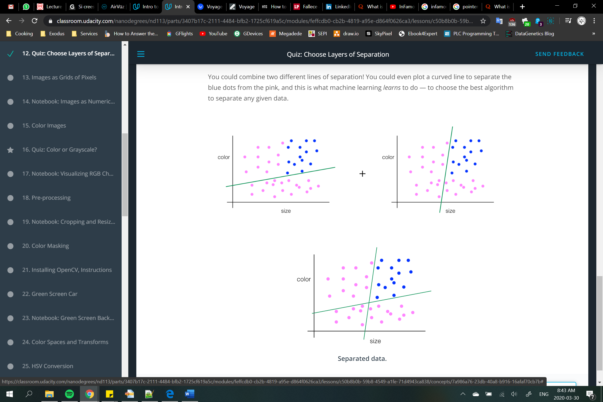

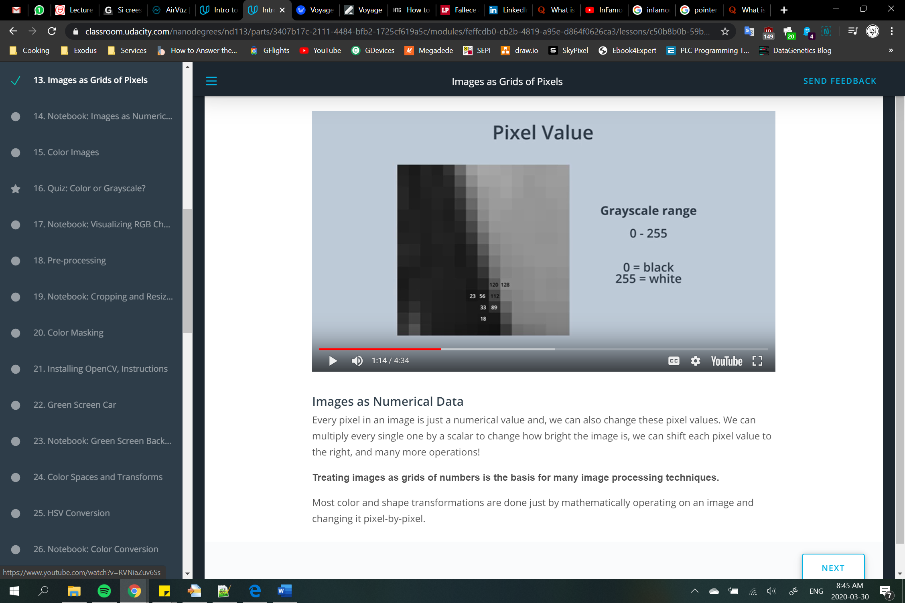

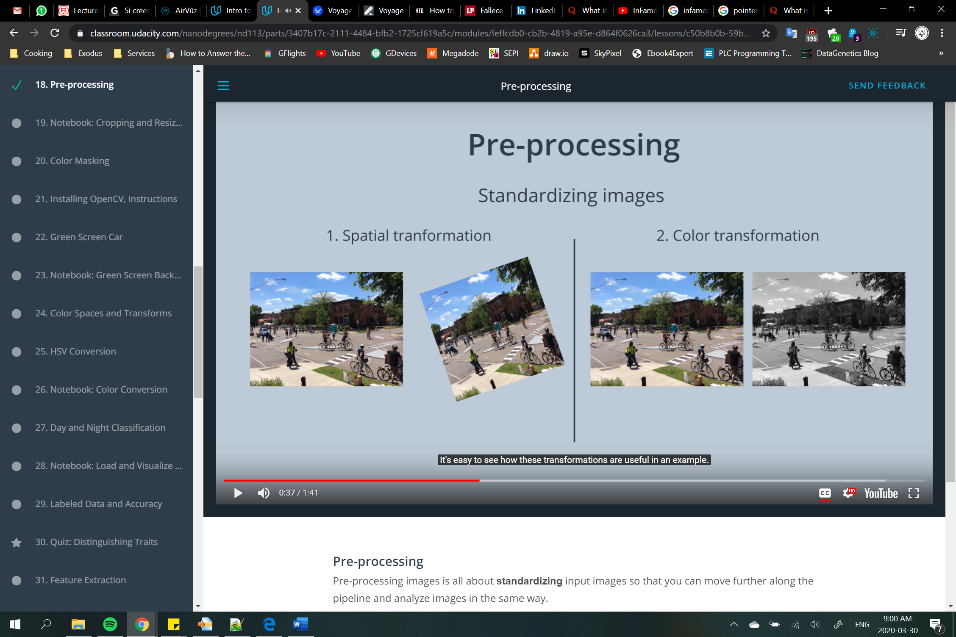

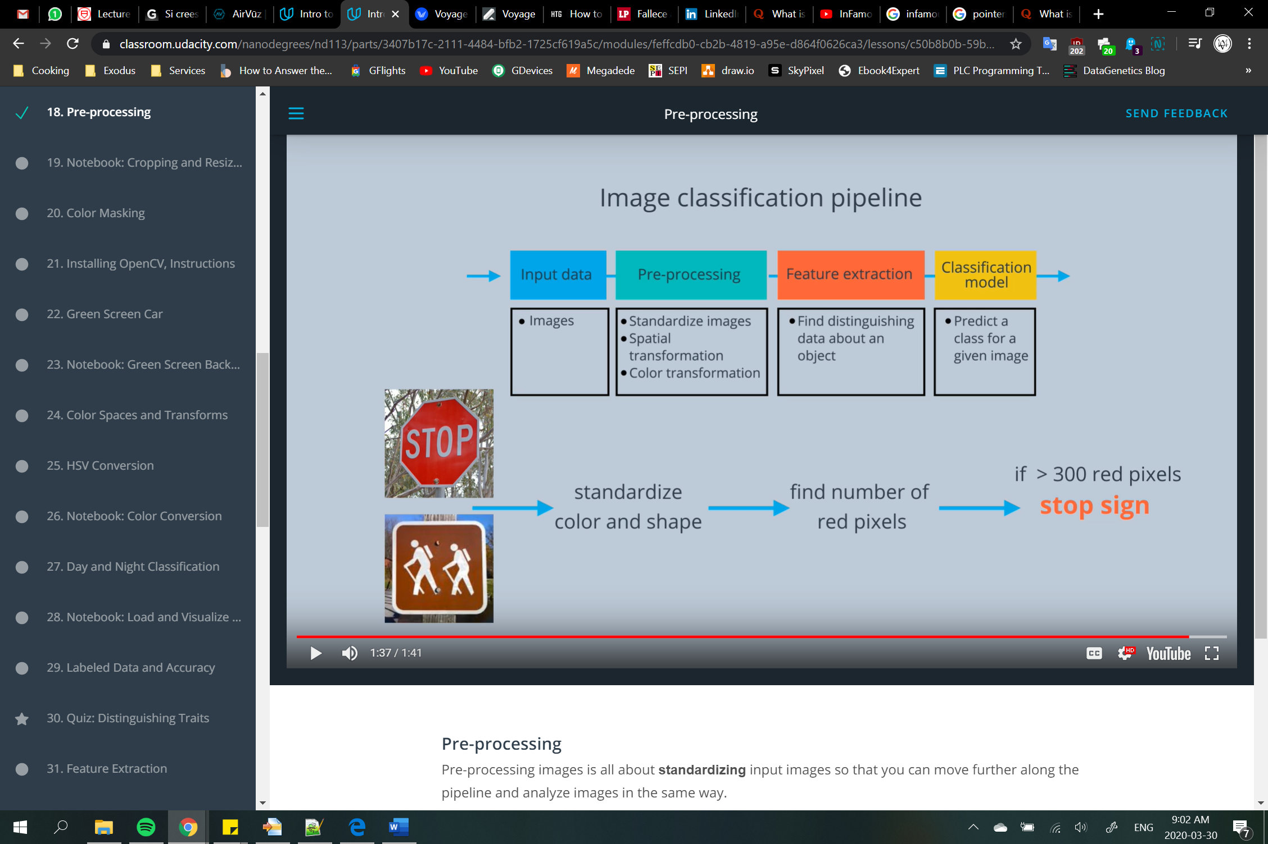



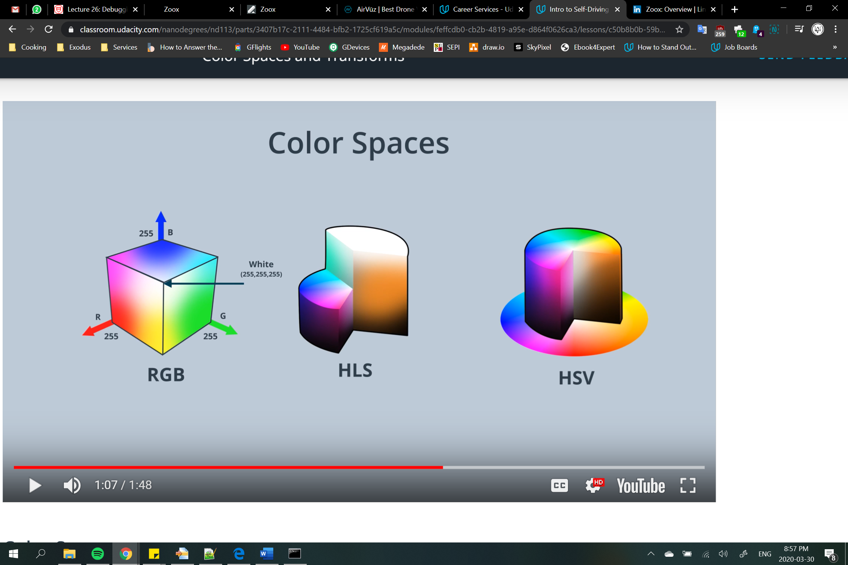

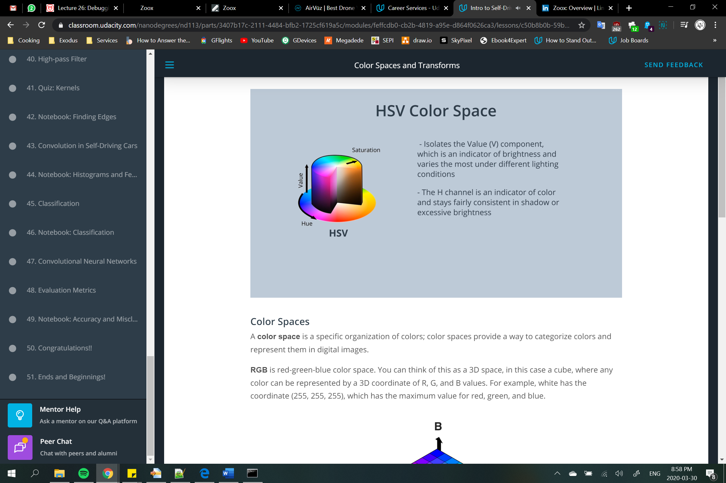

**HSV** color space (hue, saturation, and value), and **HLS** space (hue, lightness, and saturation). These are some of the most commonly used color spaces in image analysis.

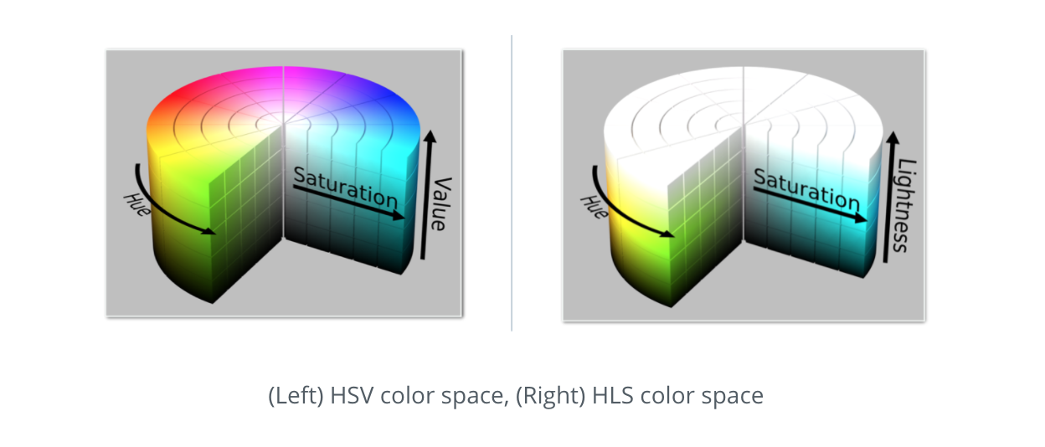

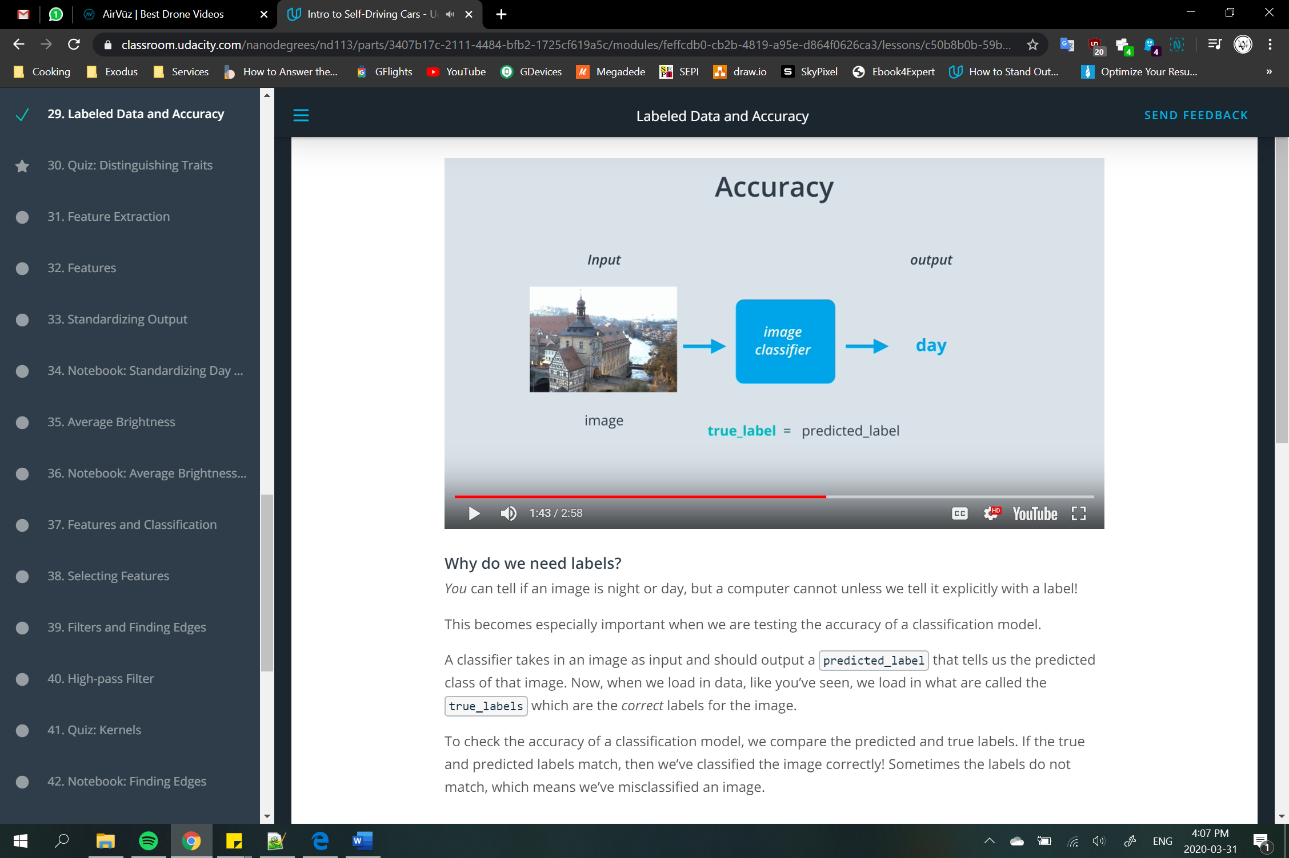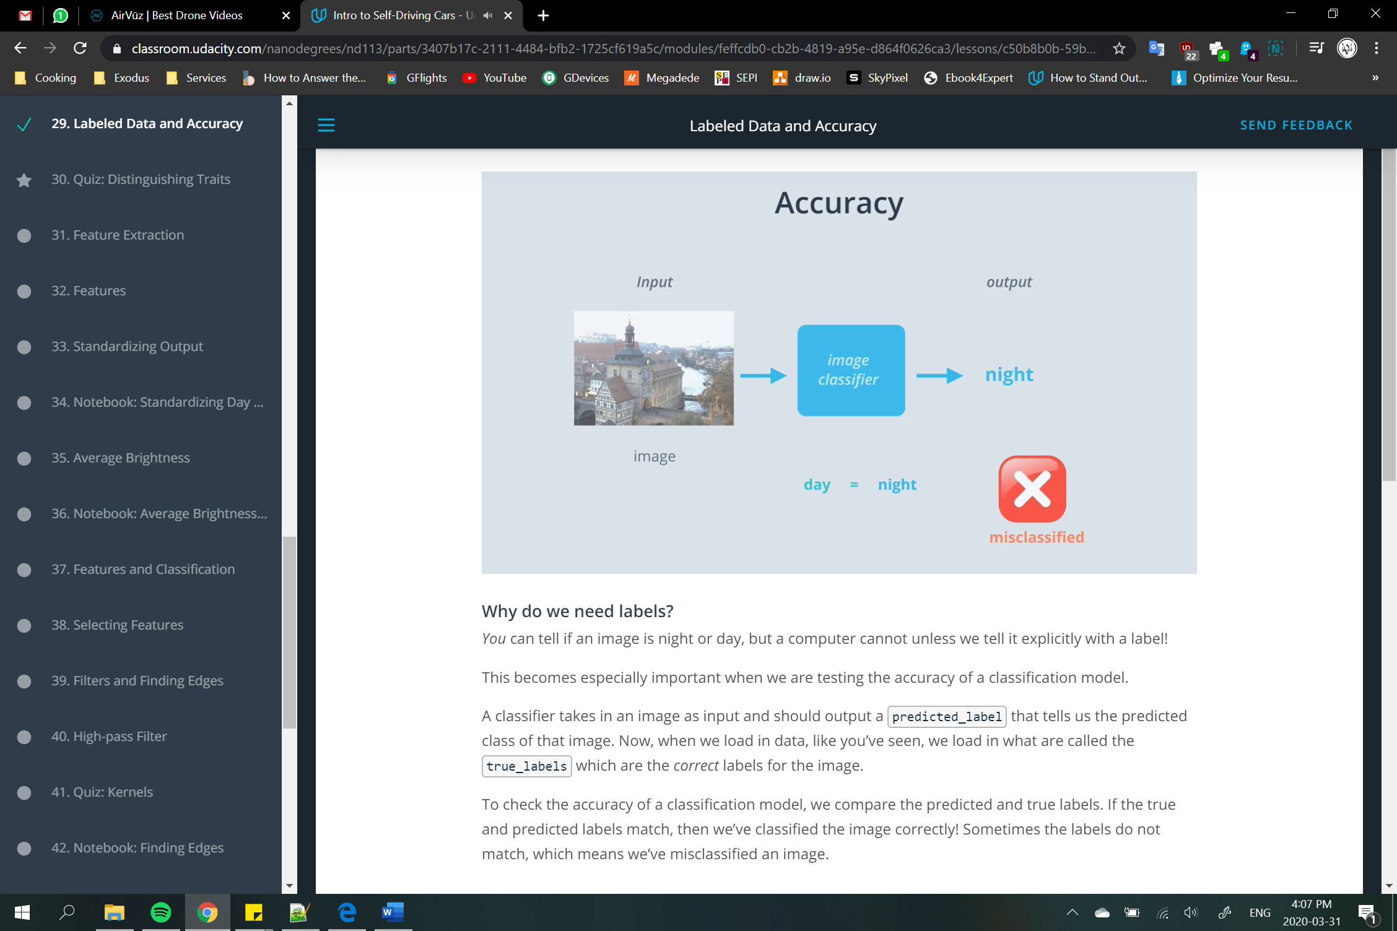



**Numerical labels**

It’s good practice to use numerical labels instead of strings or categorical labels. They're easier to track and compare.

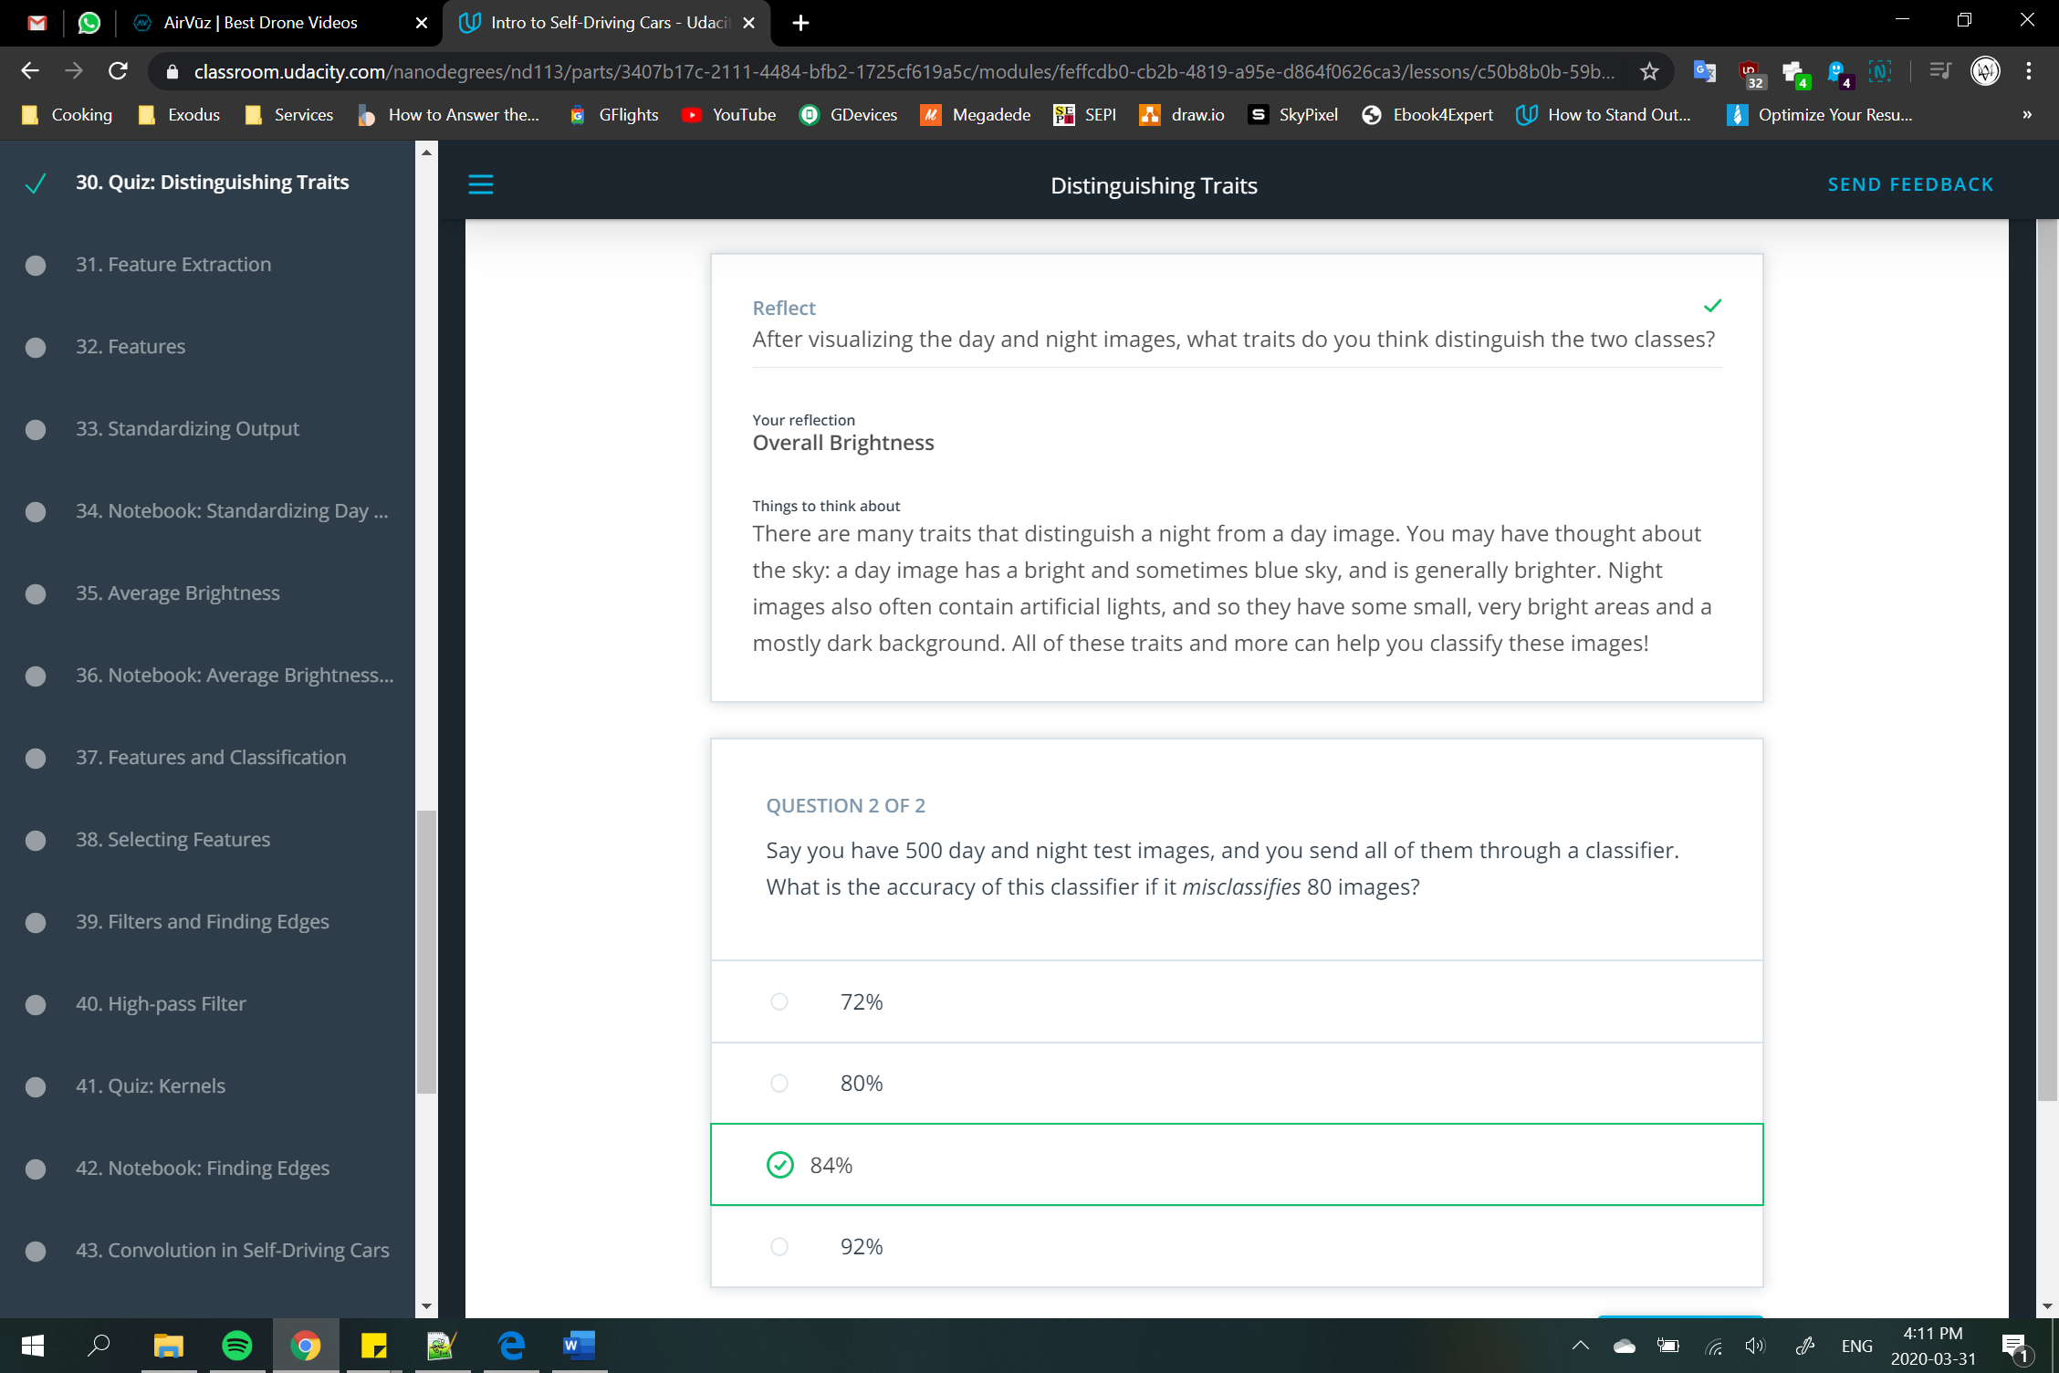

## Distinguishing and Measurable Traits

When you approach a classification challenge, you may ask yourself: how can I tell these images apart? What traits do these images have that differentiate them, and how can I write code to represent their differences? Adding on to that, how can I ignore irrelevant or overly similar parts of these images?

You may have thought about a number of distinguishing features: day images are much brighter, generally, than night images. Night images also have these really bright small spots, so the brightness over the whole image varies a lot more than the day images. There is a lot more of a gray/blue color palette in the day images.

There are lots of measurable traits that distinguish these images, and these measurable traits are referred to as **features**.

A feature a measurable component of an image or object that is, ideally, unique and recognizable under varying conditions - like under varying light or camera angle. And we’ll learn more about features soon.





